Embedding Entire Graph

# Embedding Entire Graph

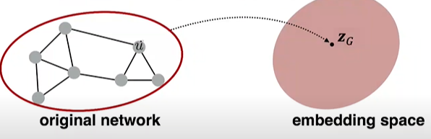**Goal** --- we want to embed a subgraph or an entire graph G, Graph embedding: zG.

**Tasks**:

* Classifying toxic vs non-toxic molecules
* Identifying anomalous graphs

**Approach 1:**

* Run a standard graph embedding technique on the (sub)graph G
* Then just sum (or average) the node embeddings in the (sub)graph G

$$z_{G}=\sum_{vϵG}{z_{v}}$$

**Approach 2:**

* 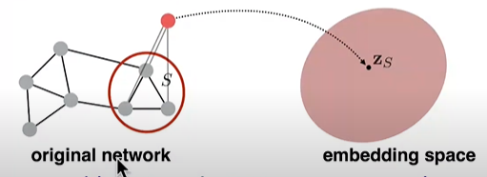Introduce a “virtual node” to represent the (sub)graph and run a standard graph embedding technique

**Approach 3 --- Anonymous Walk Embeddings:**

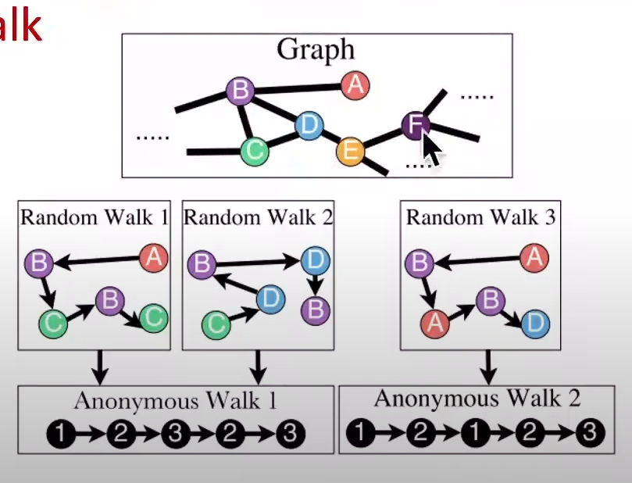States in anonymous walks correspond to the index of the first time we visited the node in a random walk.

Agnostic to the identity of the nodes visited (hence anonymous)

Example RW1:

**Step 1**: node A 🡪 node 1

**Step 2**: node B 🡪 node 2 (different from node 1)

**Step 3**: node C 🡪 node 3 (different from node 1, 2)

**Step 4**: node B 🡪 node 2 (same node in step 2)

**Step 5**: node C 🡪 node 3 (same node in step 3)

**Note**: RW2 gives the same anonymous walk

**Number of walks grows:**

Figure Length of Anonymous Walks

For example: There are 5 anonymous walks wi of length 3:

w1 = 111, w2 = 112, w3 = 121, w4 = 122, w5 = 123

# Simple Use of Anonymous Walks

* Simulate anonymous walks wi of l steps and record their counts
* Represent the graph as a probability distribution over these walks

For example:

Set L = 3

Then we can represent the graph as a 5-dim vector:

* Since there are 5 anonymous walks wi of length 3: 111, 112, 121, 122, 123
* ZG[i] = probability of anonymous walk wi in G

# Sampling Anonymous Walks

Sampling anonymous walks --- Generate independently a set of m random walks

Represent the graph as a probability distribution over these walks

How many random walks m do we need?

* We want the distribution to have error of more than with $ε$ prob less than $δ$:

$$m=[\frac{2}{ε^{2}}(\log\left(2^{η}-2\right)-log⁡(δ)]$$

Where $η$ is the total number of anonymous walks of length L.

**For example:**

There are $η$ = 877 anonymous walks of length L = 7. If we set $ε$ = 0.1 and $δ$ = 0.01 then we need to generate m = 122,500 random walks.

# New idea --- Learn Walk Embeddings

Rather than simply represent each walk by the fraction of times it occurs, we learn embedding zi of anonymous walk wi

* Learn a graph embedding ZG together with all the anonymous walk embeddings zi

Z = {zi: i = 1 …… $η$}， Where $η$ is the number of sampled anonymous walks

**How to embed walks?**

**Idea**: Embed walks s.t. the next walk can be predicted.

* A vector parameter zG for input graph
* The embedding of entire graph to be learned
* 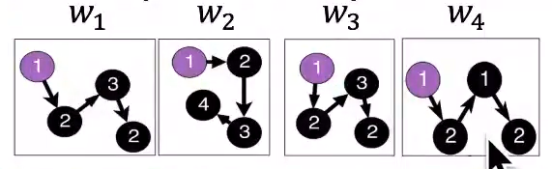Starting from node 1: Sample anonymous random walks, e.g.
* Learn to predict walks that co-occur in $∆$-size window (e.g. predict w2 given w1, w3 if $∆$ = 1)

**Objective:**

$$max\sum_{t=∆}^{T-∆}{logP(w_{t}|w_{t-∆},…,w_{t+∆}, Z_{G})}$$

* Sum the objective over all nodes in the graph
* Run T different random walks from u each of length l:
$$N_{R}\left(u\right)=\{w_{1}^{u}, w_{2}^{u}, …, w_{T}^{u}\}$$

* Learn to predict walks that co-occur in $∆$-size window
* Estimate embedding zi of anonymous walk wi

Let $η$ be number of all possible walk embeddings

Objective: $$m{ax}_{z,d}\frac{1}{T}\sum_{t=∆}^{T-∆}{logP(w_{t}|\{w_{t-∆},…,w_{t+∆}, Z_{G}\})}$$

* $P(w_{t}|\{w_{t-∆},…,w_{t+∆}, Z_{G}\}$) = $\frac{exp⁡(y\left(w_{t}\right))}{\sum_{i=1}^{η}{exp⁡(y\left(w_{i}\right))}}$
* $\sum_{i=1}^{η}{exp⁡(y\left(w_{i}\right))}$--- All possible walks (require negative sampling)
$y\left(wt\right)=b+U∙(cat\left(\frac{1}{2∆}\sum_{i=-∆}^{∆}{z_{i}},z_{G}\right))$

* $cat\left(\frac{1}{2∆}\sum_{i=-∆}^{∆}{z_{i}},z_{G}\right)$ means an average of anonymous walk embeddings in window, concatenated with the graph embedding zG
* --- are learnable parameters. This represents a linear layer.
* We obtain the graph embedding zG (learnable parameter) after optimization
* Use zG to make predictions (e.g., graph classification)
* Option 1: Inner product kernel $z_{G_{1}}^{T}z_{G_{2}}$
* Option 2: Use a neural network that take zG as input to classify

# Summary

We discussed 3 ideas to graph embeddings:

* Approach 1: Embed nodes and sum/avg them
* Approach 2: Create super-node that spans the (sub)graph and then embed that node
* Approach 3: Anonymous Walk Embeddings:
* Idea 1: Sample the anonymous walks and represent the graph as fraction of times each anonymous walk occurs
* Idea 2: Embed anonymous walks, concatenate their embeddings to get a graph embedding.

# How to use embeddings

How to use embeddings zi of nodes:

* Clustering/Community Detection --- cluster points zi
* Node Classification --- Predict label of node i based on zi
* Link Prediction --- Predict edge (i, j) based on (zi, zj)

Where we can: cancatenate, avg, product, or take a difference between the embeddings:

* Concatenate: $f\left(z_{i},z_{j}\right)=g(\left[z_{i},z_{j}\right])$
* Hadamard: $f\left(z_{i},z_{j}\right)=g(z_{i}*z_{j})$ (per coordinate product
* Sum/Avg: $f\left(z_{i},z_{j}\right)=g(z_{i}+z_{j})$
* Distance: $f\left(z_{i},z_{j}\right)={g(|\left|z_{i}+z_{j}\right||}_{2})$
* Graph Classification --- graph embedding zG via aggregating node embeddings or anonymous random walks. Predict label based on graph embedding zG